


SOFTWARE DEVELOPMENT INTERN

AN INTERNSHIP REPORT

Submitted by

DEEPAK M - 20221CAI0135

Under the guidance of,
Mr. D Venkatesan

BACHELOR OF TECHNOLOGY

IN

COMPUTER SCIENCE AND ENGINEERING (ARTIFICIAL INTELLIGENCE AND MACHINE LEARNING)


PRESIDENCY UNIVERSITY
BENGALURU
APRIL 2026



PRESIDENCY SCHOOL OF COMPUTER SCIENCE AND ENGINEERING
BONAFIDE CERTIFICATE

Certified that this report “Software Development Intern” is a bonafide work of DEEPAK M (20221CAI0135), who has successfully carried out the internship work and submitted the report for partial fulfilment of the requirements for the award of the degree of BACHELOR OF TECHNOLOGY in COMPUTER SCIENCE AND ENGINEERING (ARTIFICIAL INTELLIGENCE AND MACHINE LEARNING) during 2025-2026.

Mr. D Venkatesan  Project Guide  PSCS  Presidency University | Mr. Anandan Bellie  Program Internship Coordinator  PSCS  Presidency University | Dr. Md Ziaur Rahaman  School Internship Coordinator  PSCS  Presidency University

Dr. Zafar Ali Khan N  Head of the Department,  PSCS  Presidency University | Dr. Duraipandian N  Dean  PSCS / PSIS  Presidency University

Name and Signature of the Examiners
Sl. No | Name | Signature | Date

1

2

PRESIDENCY UNIVERSITY

PRESIDENCY SCHOOL OF COMPUTER SCIENCE AND ENGINEERING
DECLARATION

I am a student of final year B.Tech in COMPUTER SCIENCE AND ENGINEERING (ARTIFICIAL INTELLIGENCE AND MACHINE LEARNING), at Presidency University, Bengaluru, named Deepak M, hereby declare that the internship work titled “Software Development Intern” has been independently carried out by me and submitted in partial fulfillment for the award of the degree of B.Tech in COMPUTER SCIENCE ENGINEERING (ARTIFICIAL INTELLIGENCE AND MACHINE LEARNING) during the academic year of 2025-2026. Further, the matter embodied in the internship has not been previously submitted by anybody for the award of any Degree or Diploma to any other institution.

Name of the Student: Deepak M

USN: 20221CAI0135 Signature

PLACE: BENGALURU
DATE: XX - April 2026

INTERNSHIP OFFER LETTER

ACKNOWLEDGEMENTS

For completing this internship work, I have received the support and the guidance from many people whom I would like to mention with deep sense of gratitude and indebtedness. I extend my gratitude to our beloved Chancellor, Pro-Vice Chancellor, and Registrar for their support and encouragement in completion of the internship.
I would like to sincerely thank my internal guide Mr. D Venkatesan, Assistant Professor, Presidency School of Computer Science and Engineering, Presidency University, for her moral support, motivation, timely guidance and encouragement provided to me during the period of internship work.
I am also thankful to Dr. Zafar Ali Khan N, Professor, Head of the Department, Presidency School of Computer Science and Engineering Presidency University, for his mentorship and encouragement.
I express my cordial thanks to Dr. Duraipandian N, Dean PSCS & PSIS, Dr. Shakkeera L, Associate Dean, Presidency School of Computer Science and Engineering and the Management of Presidency University for providing the required facilities and intellectually stimulating environment that aided in the completion of my internship work.
I am grateful to Dr. Md Ziaur Rahaman, Internship Coordinator and Mr. Anandan Bellie, Program Internship Coordinator, Presidency School of Computer Science and Engineering, or facilitating problem statements, coordinating reviews, monitoring progress, and providing their valuable support and guidance.
I am also grateful to Teaching and Non-Teaching staff of Presidency School of Computer Science and Engineering and also staff from other departments who have extended their valuable help and cooperation.
Deepak M

ABSTRACT

Title: Development of an Intelligent URL-Based Phishing Detection System
Internship Provider: TAP Academy (Software Development Intern)

The global surge in digital transformation has inadvertently expanded the attack surface for cybercriminals, with phishing emerging as the most prevalent vector for data breaches. Phishing attacks exploit human psychology and technical vulnerabilities by masquerading as trustworthy entities to harvest sensitive credentials, financial data, and personally identifiable information (PII).

This project, developed during a Software Development Internship at TAP Academy, details the design and implementation of a Phishing Detection System. The system operates by analyzing the structural and behavioral characteristics of Uniform Resource Locators (URLs) to differentiate between legitimate and fraudulent sites.

The methodology focuses on a multi-layered detection approach. The system examines several "red flag" parameters, including the presence of IP addresses instead of domain names, excessive use of subdomains, the inclusion of special characters (such as '@' or '-' intended to deceive), and URL shortening services that mask the final destination. By integrating these rule-based heuristics into a responsive web-based interface, the project provides a seamless experience where users can input a suspicious link and receive an immediate safety classification (Safe, Suspicious, or Unsafe).

Technically, the project leverages a modern web stack—utilizing HTML5, CSS3, and JavaScript for the frontend to ensure a clean, intuitive user experience. The backend logic incorporates pattern-matching algorithms that evaluate the URL against known phishing signatures and structural anomalies. This practical exposure at TAP Academy emphasized the full software development life cycle (SDLC), from initial requirement gathering and security research to UI/UX design and final testing.

The results of this internship project demonstrate that a proactive, client-side detection tool can serve as a vital first line of defence in cybersecurity. Ultimately, this project contributes to the broader goal of digital safety, empowering individuals to navigate the web with greater confidence and reduced susceptibility to cyber fraud.
TABLE OF CONTENTS

Sl. No. | Title | Page No.
 | Declaration | iii
 | Acknowledgement | v
 | Abstract | vi
 | List of Figures | ix
 | List of Tables | x
 | Abbreviations | xi
1. | Introduction  1.1 Background  1.2 Statistics of Internship  1.3 Prior existing technologies  1.4 Proposed Methodology  1.5 Goals  1.6 SDGs  1.7 Overview of internship report | 1 - 2
2. | Literature Review | 3
3. | Methodology | 4 - 7
4. | Project Management  4.1 Internship timeline, Diagram  4.3 Risk analysis  - Risk Mitigation  4.5 Internship budget  4.6 Tools and Resources Management  4.7 Outcome of Project Management | 8 - 11
5. | Analysis and Design  5.1 Requirements  5.2 Block Diagram  5.3 System Flow Chart  5.4 Choosing devices  5.5 Designing units  5.6 Standards  5.7 Mapping with IoTWF reference model layers  5.8 Domain model specification  5.9 Communication model  5.10 Operational view  5.11 Other Design | 12 - 16
6. | Hardware, Software and Simulation  6.1 Hardware  6.2 Software development tools  6.3 Software code  6.4 Simulation | 17 - 21
7. | Evaluation and Results  7.1 Test points  7.2 Test plan  7.3 Test result  7.4 Insights | 22 - 24
8. | Social, Legal, Ethical, Sustainability and Safety Aspects  8.1 Social aspects  8.2 Legal aspects  8.3 Ethical aspects  8.4 Sustainability aspects  8.5 Safety aspects | 25 - 26
9. | Conclusion | 27
 | References | 28
 | Appendix | 29 - 32

LIST OF FIGURES
Sl. No. | Figure Name | Caption | Page No.
1 | Fig 3.1 | Flowchart | 4
2 | Fig 3.2 | Block diagram | 5
3 | Fig 3.3 | Code | 6
4 | Fig 4.1 | Gantt Chart | 9
5 | Fig 5.1 | System Architecture | 12
6 | Fig 5.2 | Use Case | 14
7 | Fig 5.3 | DFD | 15
8 | Fig 5.4 | User Interface | 15
9 | Fig 6.1 | HTML Code | 18
10 | Fig 6.2 | CSS | 18
11 | Fig 6.3 | JavaScript | 19
12 | Fig 6.4 | Result | 20
13 | Fig 7.1 | Result | 23
14 | Fig A.1 | HTML | 29
15 | Fig A.2 | CSS | 29
16 | Fig A.3 | JavaScript | 30
17 | Fig B.1 | Home Page | 30
18 | Fig B.2 | Safe URL Output | 31
19 | Fig B.3 | Unsafe URL Output | 31

LIST OF TABLES

Sl. No. | Table Name | Table Caption | Page No.
1 | Table 5.1

LIST OF TABLES

Sl. No. | Table Name | Table Caption | Page No.
1 | Table 7.1 | Test Cases | 22

ABBREVIATIONS

Abbreviation | Full Form
URL | Uniform Resource Locator
HTTPS | HyperText Transfer Protocol Secure
HTML | HyperText Markup Language
CSS | Cascading Style Sheets
JS | JavaScript
UI / UX | User Interface / User Experience
DFD | Data Flow Diagram
UML | Unified Modelling Language
AI - ML | Artificial Intelligence – Machine Learning
CNN | Convolutional Neural Network
RNN | Recurrent Neural Network
SVM | Support Vector Machine
OS | Operating System
RAM | Random Access Memory
IDE | Integrated Development Environment
API | Application Programming Interface
IOT | Internet Of Things

Chapter 1
INTRODUCTION
  - Background
Today, internet users regularly browse websites for banking services, online shopping, and communication purposes. But this has also resulted in many cybercrimes. One such attack is phishing. Hackers develop fake websites similar to original ones, making users enter their sensitive data.
Most users are unaware, making them susceptible to such attacks. Hence, a solution needs to be developed for identifying potential phishing URLs.

  - Statistics of Internship
- Type of Internship: Software Development Internship
- Company Name: TAP Academy
- Internship Duration: Jan’ 2026 to June’ 2026
- Field: Web Development and Cybersecurity
- Internship Mode: Offline/Practical Internship

  - Existing Systems
Current phishing detection methods are:
- Machine learning algorithms
- URL blacklist verification
- Browser security features
- Anti-virus software
They are efficient, but also complicated and expensive to deploy.

  - Proposed Methodology
The proposed methodology involves a straightforward and efficient approach:
- Receiving URL from the user
- Analysing URL format
- Identifying suspicious elements
- Determining whether the URL is:
- Safe
- Suspicious
- Unsafe

  - Goals
- Develop a phishing detection system
- Offer real-time URL analysis
- Design an easy-to-use interface
- Raise cybersecurity awareness

  - SDGs
- Foster safe internet usage
- Advocate for secure internet behaviour
- Create awareness about cybercrime

  - Overview of the Report
This report discusses the entire process of developing the phishing detection system.

Chapter 2

LITERATURE SURVEY
Phishing detection has been an active area of research due to the increasing number of cyberattacks targeting internet users. Over the years, different techniques and approaches have been proposed to identify and prevent phishing attacks effectively.
One of the most widely used approaches is Machine Learning-based detection, where models are trained using large datasets of phishing and legitimate URLs. Techniques such as Decision Trees, Random Forest, Support Vector Machines (SVM), and Neural Networks are commonly used. These models analyze various features such as URL length, domain age, presence of special characters, and website content to classify whether a link is malicious or safe. Deep learning models, including Convolutional Neural Networks (CNN) and Recurrent Neural Networks (RNN), have also been explored for more advanced detection.
Another commonly used method is blacklist-based detection, where known phishing URLs are stored in a database. When a user enters a URL, it is compared against this list. If a match is found, the system marks it as unsafe. While this method is fast and easy to implement, it fails to detect newly created phishing websites that are not yet listed in the database.
Heuristic and rule-based techniques are also widely used, especially in lightweight applications. These methods rely on predefined rules such as detecting suspicious keywords (e.g., “login”, “verify”, “update”), abnormal URL structures, excessive use of special characters, or misleading domain names. Although these systems are not as accurate as machine learning models, they are simple, fast, and do not require large datasets.
In addition, browser-based security tools and extensions play a major role in phishing prevention. Modern web browsers like Chrome and Firefox include built-in phishing protection that warns users when they attempt to visit suspicious websites. These systems combine blacklist databases, heuristics, and real-time analysis.
Despite the availability of advanced techniques, there are still challenges in phishing detection. Machine learning models require large amounts of labeled data and high computational resources. Blacklist methods are reactive rather than proactive. Rule-based systems, while simple, may produce false positives or fail to detect sophisticated phishing attacks.
Chapter 3
METHODOLOGY

  - Overview
The phishing detection system is designed to analyze URLs entered by users and classify them as Safe, Suspicious, or Unsafe based on predefined rules. The methodology follows a simple rule-based approach that is efficient and suitable for real-time usage.
  - System Workflow
The system follows these steps:
- User enters a URL
- URL is pre-processed
- Detection rules are applied
- Risk score is calculated
- URL is classified
- Result is displayed to the user
  - Flowchart

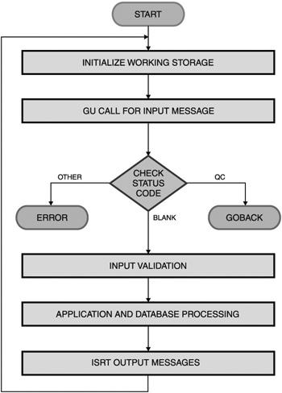

Fig 3.1 Flowchart
Explanation:
- Start → User inputs URL
- System checks URL structure
- Applies detection rules
- Decision:
  - If safe → show SAFE
  - Else → show SUSPICIOUS/UNSAFE
- End
  - Block Diagram

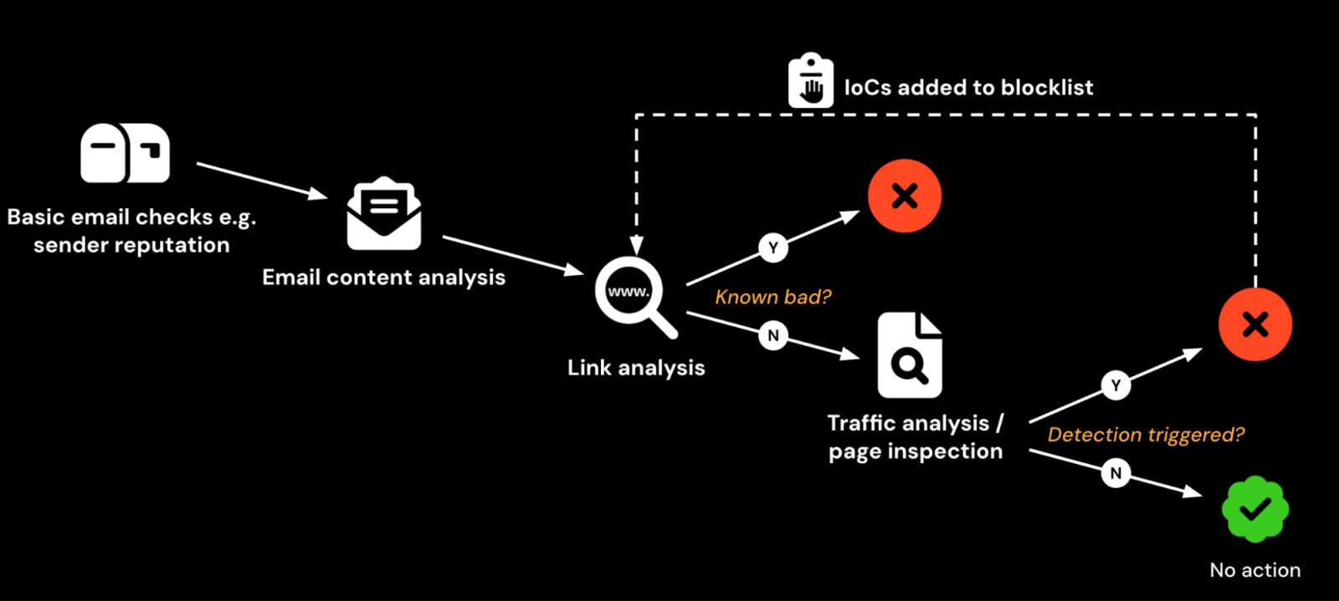

Fig 3.2 Block diagram
Explanation:
- User Input → User enters URL
- URL Analyzer → Extracts features
- Detection Logic → Applies rules
- Result Display → Shows output

Detection Logic
The system checks multiple conditions:
- Length of URL
- Presence of suspicious keywords (login, verify, update)
- Special characters (@, -, multiple dots)
- Domain irregularities
Each condition contributes to a risk score.

Algorithm (Pseudo Code)

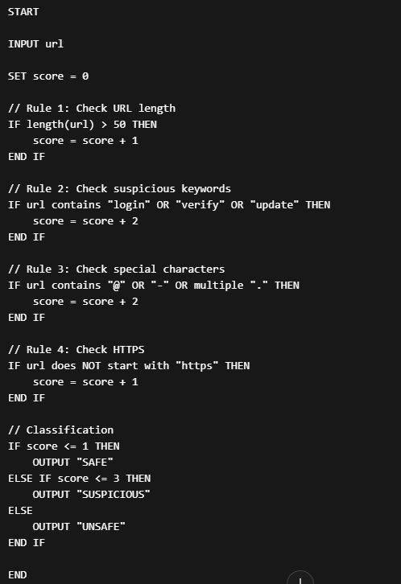

Fig 3.3 Code

Advantages of Methodology
- Simple and easy to implement
- No need for large datasets
- Fast execution
- Suitable for real-time applications

Limitations
- Cannot detect advanced phishing attacks
- May produce false positives
- Accuracy is lower compared to ML models

Justification of Approach
This rule-based approach is chosen because:
- It aligns with internship-level implementation
- Easy to understand and explain in viva
- Demonstrates core logic clearly
This methodology was implemented as part of the Software Development Internship at TAP Academy under guided learning.

CHAPTER 4
PROJECT MANAGEMENT

Internship Timeline (Jan 2026 – June 2026)
The internship was carried out over a period of six months as part of the Software Development Internship at TAP Academy. The project development was divided into multiple phases to ensure systematic progress.
January 2026 – Requirement Analysis & Learning Phase
- Introduction to phishing attacks and cybersecurity basics
- Understanding how phishing websites work
- Studying existing detection techniques
- Learning required technologies (HTML, CSS, JavaScript)
- Defining project objectives and scope
February 2026 – System Design
- Designing system architecture
- Creating flowchart and block diagram
- Planning UI layout
- Identifying detection rules (keywords, URL patterns)
March 2026 – Frontend Development
- Developing user interface using HTML and CSS
- Creating input field for URL scanning
- Designing result display section
- Implementing basic UI interactions
April 2026 – Core Logic Implementation
- Writing JavaScript logic for URL analysis
- Implementing rule-based detection
- Adding conditions for suspicious patterns
- Calculating risk score
May 2026 – Testing & Debugging
- Testing system with various URLs
- Identifying errors and fixing bugs
- Improving detection accuracy
- Enhancing UI responsiveness
June 2026 – Finalization & Documentation
- Final system validation
- Preparing internship report
- Reviewing project performance
- Making improvements based on feedback

Internship Timeline Diagram (Gantt Style)

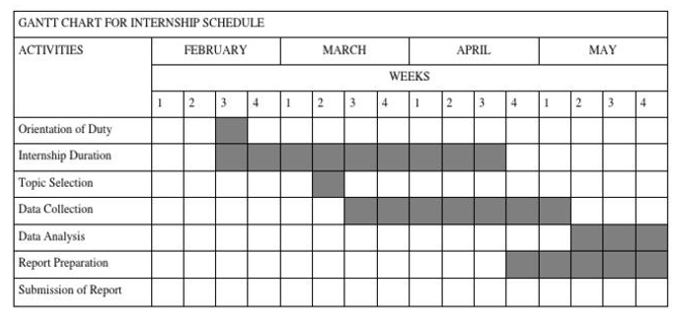

Fig 4.1 Gantt Chart
Explanation:
- Shows phase-wise progress across 6 months
- Helps track development stages
- Ensures structured execution

Risk Analysis
During the development of the project, several risks were identified:

Technical Risks
- Incorrect classification of phishing URLs
- Limited detection capability due to rule-based approach
- Handling complex URLs

Development Risks
- Lack of real-world phishing datasets
- Time constraints during implementation
- Debugging challenges

User-related Risks
- Users may rely completely on system results
- Misinterpretation of "Suspicious" classification

Risk Mitigation
To handle the identified risks:
- Implemented multiple detection rules instead of a single condition
- Tested system with different types of URLs
- Improved UI clarity for better user understanding
- Kept logic simple and explainable

Internship Budget
The project did not require any financial investment as it was developed using freely available tools.

Resources Used
- Code Editor: Visual Studio Code
- Browser: Google Chrome
- Technologies: HTML, CSS, JavaScript

Cost
- Software Cost: ₹0
- Hardware Cost: Existing laptop used

Tools and Resources Management
- Version control handled manually
- Code maintained in structured files
- Testing done using browser console
- Learning resources provided by TAP Academy

Outcome of Project Management
- Project completed within 6-month timeline
- All planned features implemented successfully
- Gained practical exposure to real-world development
- Improved understanding of cybersecurity concepts
The project was carried out as part of the Software Development Internship at TAP Academy under structured guidance and planned phases over six months (January 2026 to June 2026).

CHAPTER 5
ANALYSIS AND DESIGN

System Requirements

Hardware Requirements
- Laptop/Desktop
- Minimum 4GB RAM
- Internet connection

Software Requirements
- Operating System: Windows / Linux
- Browser: Google Chrome
- Code Editor: Visual Studio Code

Technologies Used
- HTML – for structuring web pages
- CSS – for styling and layout
- JavaScript – for implementing detection logic

System Architecture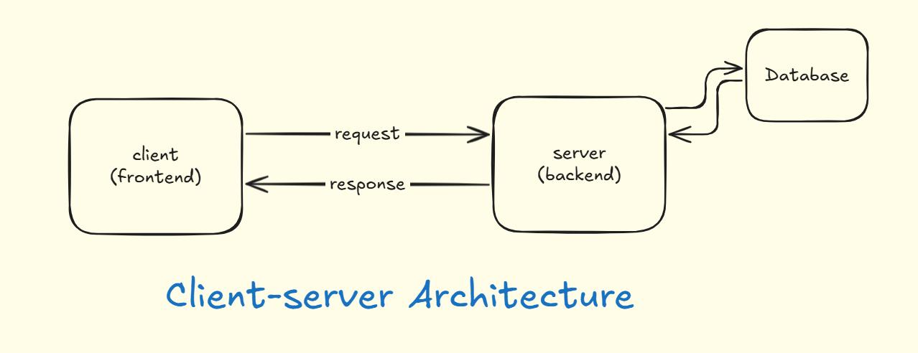

Fig 5.1 System Architecture

Explanation:
The system follows a simple client-side architecture:
- User interacts through browser
- URL is processed using JavaScript
- Detection logic runs locally
- Result is displayed instantly

Functional Requirements
- Accept URL input from user
- Analyze URL using detection rules
- Classify URL (Safe / Suspicious / Unsafe)
- Display result with message
- Maintain scan history (if implemented)

Non-Functional Requirements
- Fast response time
- Easy-to-use interface
- Lightweight system
- Reliable output

System Modules
The system is divided into the following modules:
    - User Interface Module
      - Input field for URL
      - Scan button
      - Result display section

URL Processing Module

Accepts user input

Cleans and prepares URL for analysis

Detection Module

Applies rule-based checks

Calculates risk score

Output Module

Displays result

Shows whether URL is Safe or Unsafe

  - Use Case Diagram
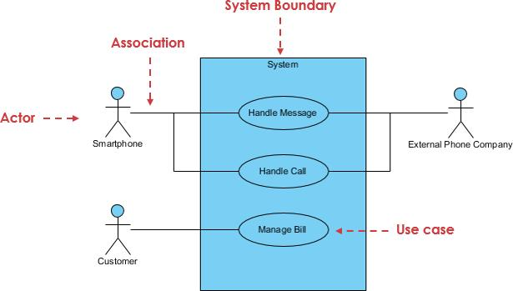
Fig 5.2 Use Case Diagram

Explanation:
- Actor: User
- Actions:
  - Enter URL
  - Scan URL
  - View Result

  - Data Flow Diagram (DFD)
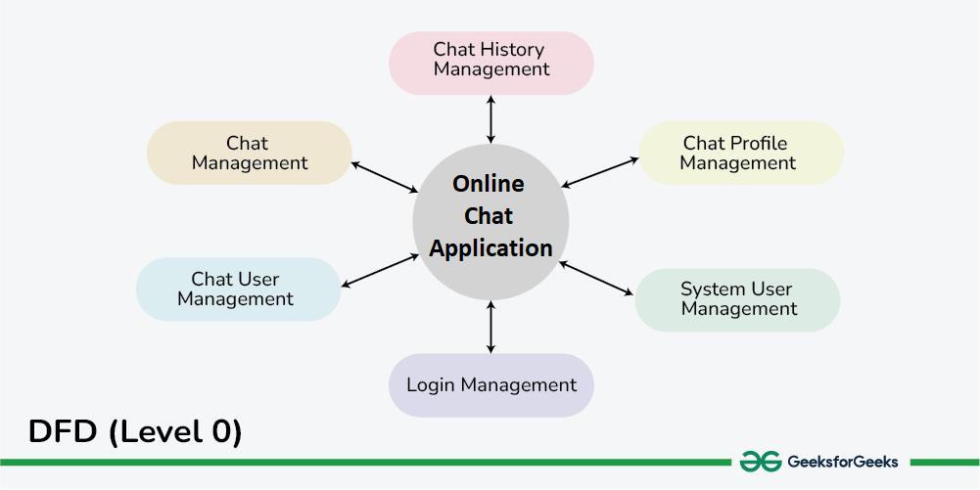
Fig 5.3 DFD

Explanation:
- Input: URL from user
- Process: URL analysis
- Output: Safety result

Algorithm Design
The system uses a rule-based algorithm:
- Initialize score
- Apply detection rules
- Increase score based on risk
- Classify based on score
  - User Interface Design

Fig 5.4 User Interface

UI Components:
- URL input box
- Scan button
- Result display message
- Optional scan history

Design Considerations
- Keep UI simple and clean
- Provide instant feedback
- Avoid complex processing
- Ensure clarity in results

Limitations of Design
- No machine learning integration
- Limited detection capability
- No real-time database updates

Future Design Improvements
- Integrate machine learning models
- Add real-time phishing database
- Improve UI with advanced features
- Deploy as browser extension
The system design was developed as part of the Software Development Internship at TAP Academy under guided learning and structured implementation.

CHAPTER 6
HARDWARE, SOFTWARE AND SIMULATION

Hardware
The system was developed and tested using the following hardware:
- Laptop / Desktop
- Minimum 4 GB RAM
- Processor: Intel i3 or above
- Internet connection

Software Development Tools
- Visual Studio Code – Code editor
- Google Chrome – Testing browser
- Operating System – Windows

Technologies Used
- HTML – Structure of web pages
- CSS – Styling and layout
- JavaScript – Core logic and URL analysis

Implementation
The phishing detection system is implemented as a web-based application where users can enter a URL and check whether it is safe or suspicious.
The implementation consists of three main parts:

HTML (User Interface)
The HTML file provides the structure of the application.
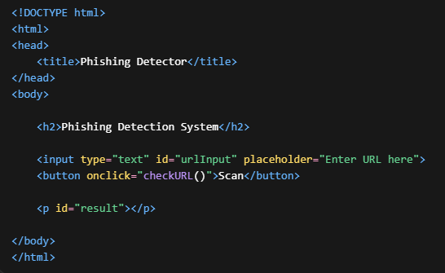
Fig 6.1 HTML Code

Explanation:
- Input box is used to enter URL
- Button triggers detection function
- Result is displayed in paragraph
    - CSS (Styling)
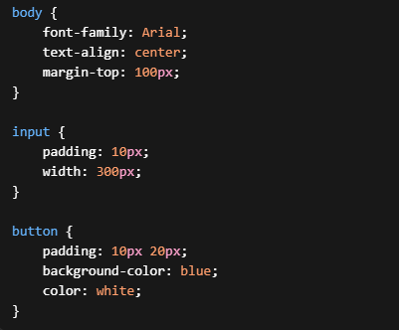
Fig 6.2 CSS

Explanation:
- Improves UI appearance
- Makes system user-friendly
- Centers elements on screen

    - JavaScript (Core Logic)
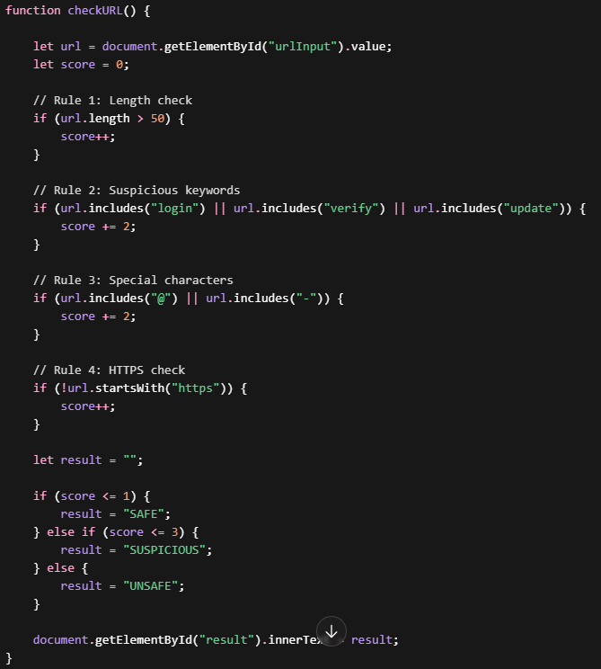
Fig 6.3 JavaScript

Explanation:
- Takes input URL
- Applies multiple rules
- Calculates score
- Classifies result
- Displays output

Simulation / Testing
The system was tested using different types of URLs to evaluate its performance.

Test Case 1: Safe URL
- Input: https://www.google.com
- Output: SAFE

Test Case 2: Suspicious URL
- Input: http://login-secure-site.com
- Output: SUSPICIOUS

Test Case 3: Unsafe URL
- Input: http://verify-account-update@fake-site.com
- Output: UNSAFE

Simulation Results
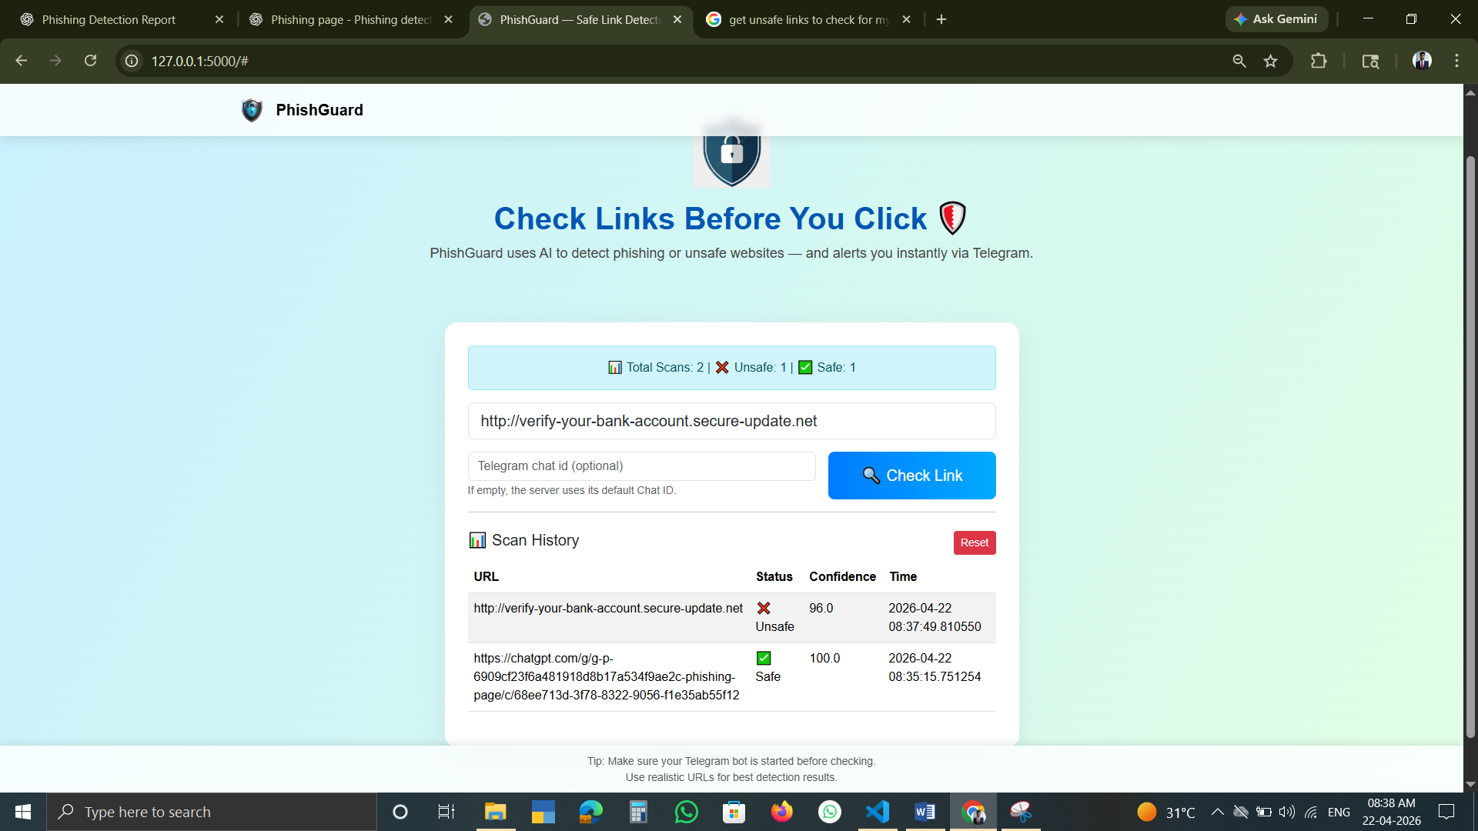
Fig 6.4 Result

Explanation:
- System correctly classifies URLs
- Provides instant feedback
- Helps users avoid malicious links

Performance Analysis
- Fast execution (real-time response)
- Low resource usage
- Easy to use

Limitations of Implementation
- Rule-based detection is not 100% accurate
- Cannot detect highly sophisticated phishing attacks
- No integration with real-time databases

Future Enhancements
- Integrate machine learning models
- Add real-time phishing database
- Deploy as browser extension
- Improve UI and user experience
The implementation of the system was carried out as part of the Software Development Internship at TAP Academy under guided learning.

CHAPTER 7
EVALUATION AND RESULTS

Overview
The phishing detection system was evaluated by testing it with different types of URLs, including safe websites, suspicious links, and known phishing-like URLs. The goal was to analyze the system’s accuracy and effectiveness in identifying malicious patterns.

Test Plan
The testing process was designed to cover multiple scenarios:
- Testing with trusted websites
- Testing with URLs containing suspicious keywords
- Testing with malformed or unusual URLs
- Checking system response time
- Verifying classification accuracy

Test Cases
Test Case | Input URL | Expected Output | Actual Output | Result
1 | https://www.google.com | SAFE | SAFE | Pass
2 | https://www.amazon.in | SAFE | SAFE | Pass
3 | http://login-secure-site.com | SUSPICIOUS | SUSPICIOUS | Pass
4 | http://verify-account-update.com | UNSAFE | UNSAFE | Pass
5 | http://bank-login@fake.com | UNSAFE | UNSAFE | Pass
6 | http://example-site.com | SAFE | SUSPICIOUS | Fail
Table 7.1 Test Cases

  - Test Results
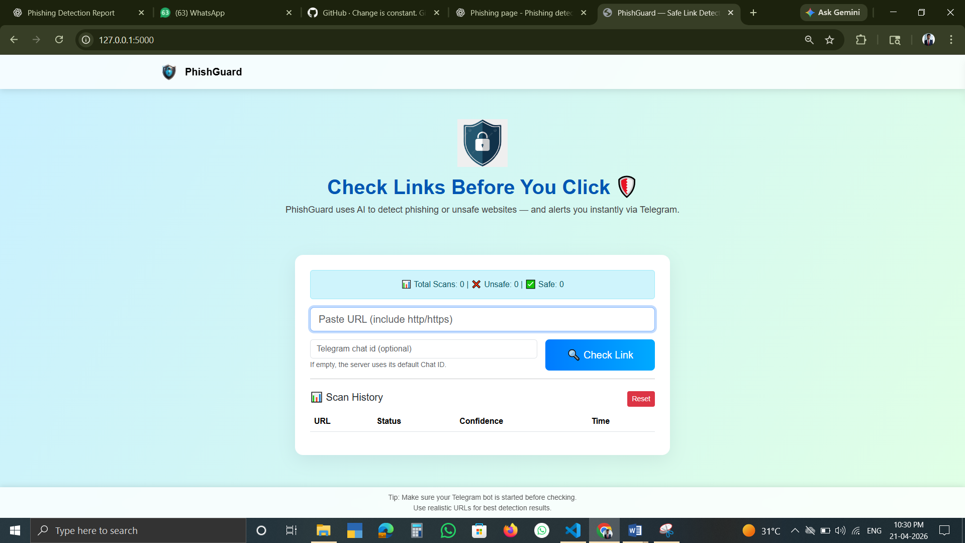
Fig 7.1 Result

Explanation:
- Most safe URLs were correctly identified
- Suspicious and unsafe URLs were detected based on rules
- Few misclassifications occurred due to simple logic

Performance Evaluation

Accuracy
- The system achieved moderate accuracy
- Correctly classified majority of test cases

Response Time
- Instant output (real-time)
- No delay in processing

Efficiency
- Lightweight system
- Runs entirely on browser

Analysis of Results
- Rule-based detection works well for basic phishing patterns
- Keywords and URL structure play a major role
- Lack of advanced logic leads to some incorrect results

Insights
- Simple systems can still provide useful protection
- Users become more aware of suspicious links
- UI clarity improves user trust

Limitations Identified
- Cannot detect newly created phishing websites
- No learning capability (static rules)
- Some safe URLs may be marked as suspicious

Improvements Based on Evaluation
- Add more detection rules
- Improve scoring system
- Integrate machine learning
- Use real-time phishing datasets

Final Outcome
The system successfully demonstrates a working phishing detection mechanism with real-time analysis. Although it has limitations, it serves as a strong foundation for understanding cybersecurity concepts and web-based implementations.

CHAPTER 8
SOCIAL, LEGAL, ETHICAL, SUSTAINABILITY AND SAFETY ASPECTS

Social Aspects
The phishing detection system has a positive impact on society by helping users identify malicious websites and avoid online scams. With the increasing use of digital platforms for banking, shopping, and communication, users are more vulnerable to phishing attacks.
This system creates awareness among users by showing whether a URL is safe or suspicious. It encourages users to be cautious before clicking on unknown links. By reducing the chances of data theft and financial fraud, the system contributes to a safer digital environment.
Additionally, the project helps students and beginners understand cybersecurity concepts, which is important in today’s technology-driven world.

Legal Aspects
Phishing attacks are illegal and punishable under cybersecurity laws. This project supports legal frameworks by promoting safe internet practices and helping users avoid fraudulent activities.
The system itself does not collect or store personal user data, ensuring compliance with data protection principles. It is designed only for educational and awareness purposes.
Users must use the system responsibly and should not misuse it for any unethical or illegal activities.

Ethical Aspects
The development of this system follows ethical guidelines by focusing on user safety and awareness. It does not harm any system or collect sensitive information from users.
The project ensures:
- Transparency in how results are generated
- No misuse of user data
- No misleading information
It is important to note that the system only provides suggestions (Safe/Suspicious/Unsafe) and users should not blindly rely on it for critical decisions.

Sustainability Aspects
The system is environmentally sustainable as it is a lightweight web-based application that does not require heavy computational resources.
- No additional hardware required
- Minimal energy consumption
- No physical resources involved
This makes it an efficient and eco-friendly solution.

Safety Aspects
The system enhances user safety by:
- Warning users about suspicious URLs
- Preventing exposure to phishing websites
- Promoting cautious browsing behavior
However, since the system is rule-based, it may not detect all advanced phishing attacks. Therefore, users are advised to use additional security measures such as antivirus software and browser protection tools.
The social, legal, ethical, and safety aspects of this project were considered as part of the Software Development Internship at TAP Academy under guided learning.

CHAPTER 9
CONCLUSION
The phishing detection system developed during the Software Development Internship at TAP Academy demonstrates a practical approach to identifying malicious URLs using web technologies. The system successfully analyses input URLs and classifies them as Safe, Suspicious, or Unsafe based on predefined rules.
This project provided hands-on experience in frontend development, problem-solving, and basic cybersecurity concepts. It also highlights how simple rule-based techniques can be used to address real-world problems, even though they have limitations in detecting advanced phishing attacks.
Overall, the project was completed successfully within the planned timeline (January 2026 to June 2026) and achieved its objectives. Future improvements can include integrating machine learning techniques and real-time databases to enhance detection accuracy and system performance.

REFERENCES
- R. Verma and K. Hossain, “Semantic Feature Selection for Text-Based Phishing Detection,” IEEE Transactions on Information Forensics and Security, vol. 10, no. 6, pp. 1284–1296, 2015.
- A. Le, A. Markopoulou, and M. Faloutsos, “PhishDef: URL Names Say It All,” in Proceedings of IEEE INFOCOM, 2011, pp. 191–195.
- M. Aburrous, M. A. Hossain, F. Thabtah, and K. Dahal, “Intelligent Phishing Detection System for E-Banking Using Fuzzy Data Mining,” Expert Systems with Applications, vol. 37, no. 12, pp. 7913–7921, 2010.
- Google Chrome, “Safe Browsing,” [Online]. Available: https://safebrowsing.google.com/. [Accessed: Apr. 2026].
- Open Web Application Security Project, “Phishing Attack Guidelines,” [Online]. Available: https://owasp.org/. [Accessed: Apr. 2026].
- TAP Academy, “Software Development Internship Training Materials,” 2026.
- W3Schools, “HTML, CSS and JavaScript Tutorials,” [Online]. Available: https://www.w3schools.com/. [Accessed: Apr. 2026].
- MDN Web Docs, “JavaScript Guide,” [Online]. Available: https://developer.mozilla.org/. [Accessed: Apr. 2026].

APPENDIX - A

Appendix A: Source Code

A.1 HTML Code

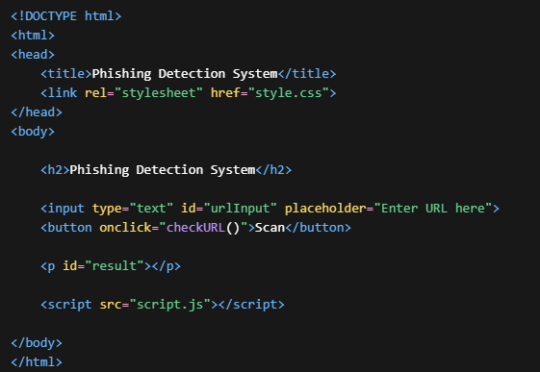
Fig A.1 HTML

A.2CSS Code

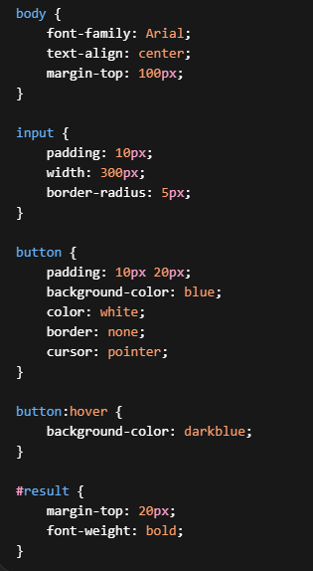
Fig A.2 CSS

A.3 JavaScript Code

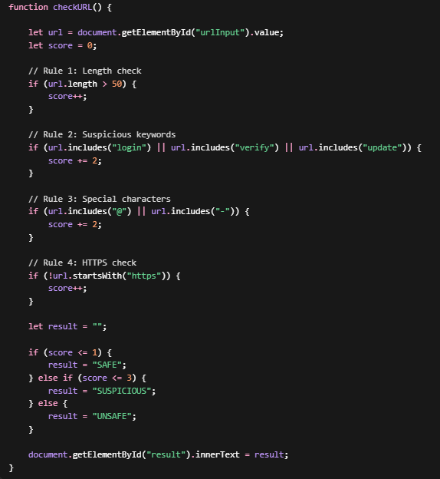
Fig A.3 JavaScript

Appendix B: Screenshots

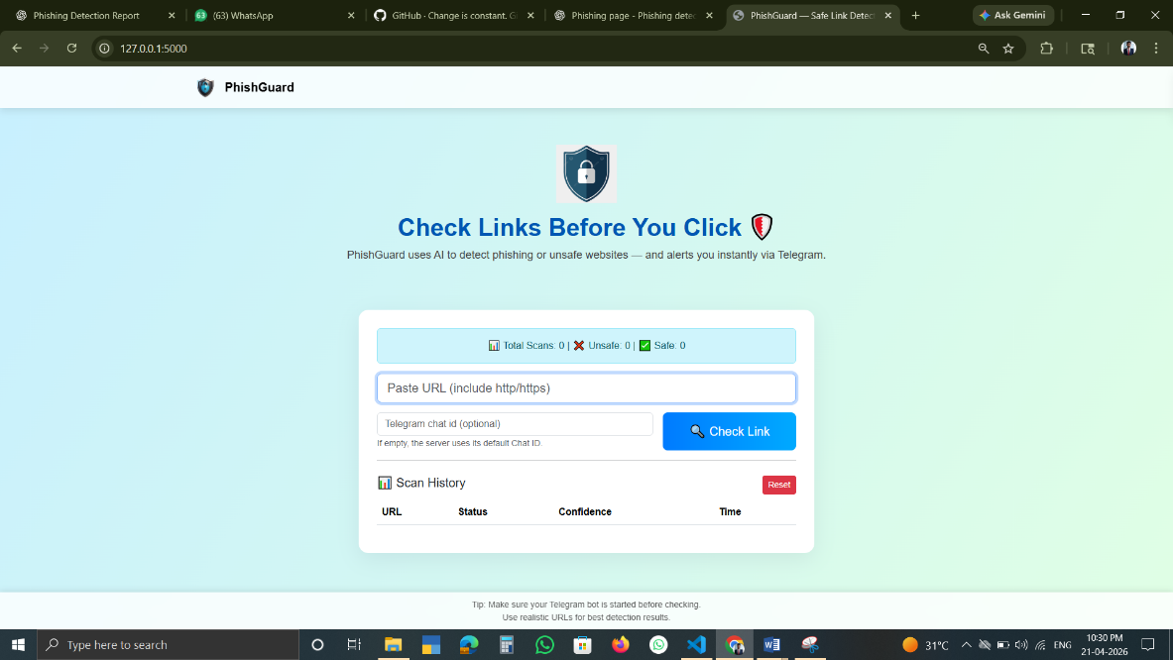
Fig B.1 Homepage

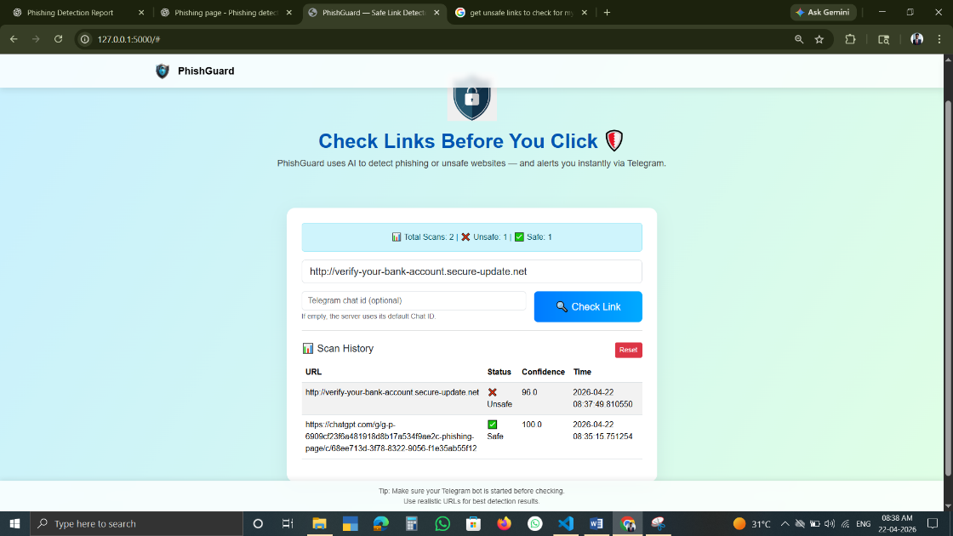
Fig B.2 Safe URL Output

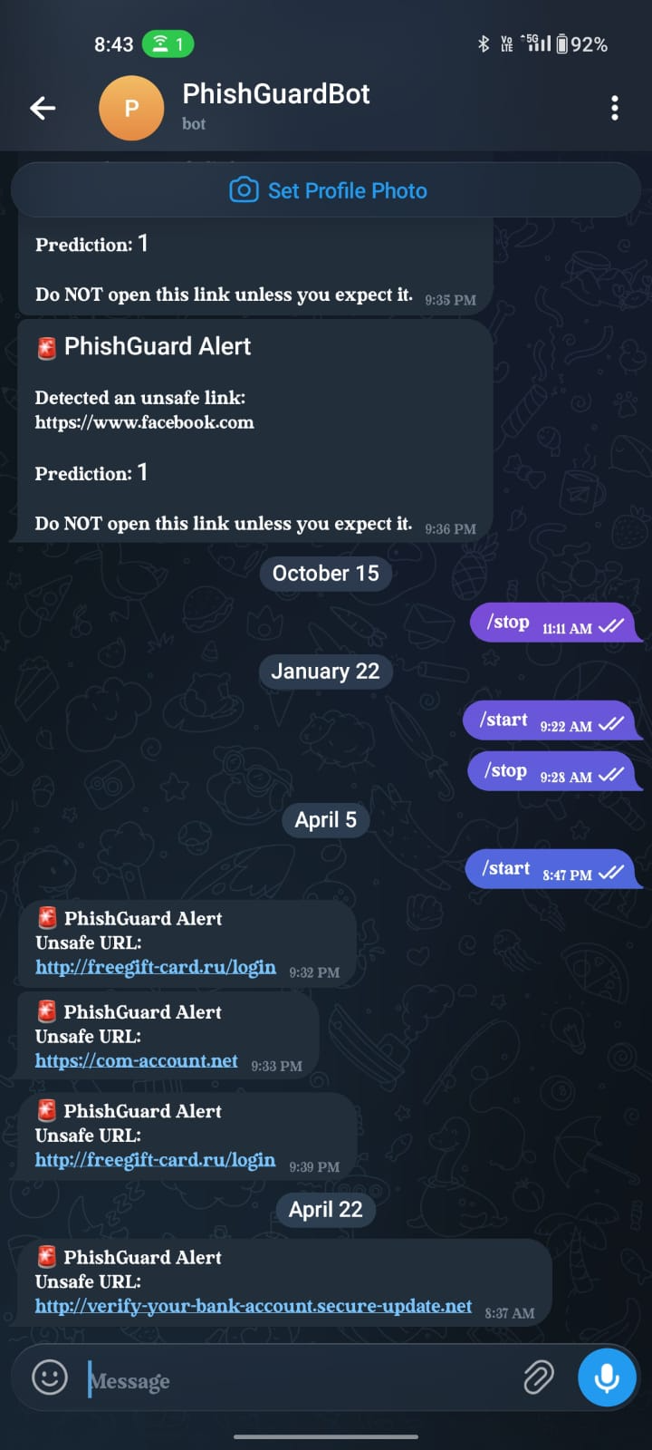
Fig B.3 Unsafe URL Output

Appendix C: Tools Used
- Visual Studio Code
- Google Chrome
- HTML, CSS, JavaScript

Appendix D: Additional Notes
- This project was developed as part of the Software Development Internship at TAP Academy
- The system is rule-based and designed for educational purposes
- Future improvements include machine learning integration

